  - Bridge Meadows
  - SUSTAINABILITY PROJECTS
Rural Crafts – Coppice Designs

Rustic Furniture Making Testimonials;

Wedding

"Many thanks for a splendid day at your workshop yesterday. Howard and I really enjoyed creating our anniversary masterpiece" (bench) Phillipa and Howard Slatter, Cambridge

Thanks again for a great day – bench has been much admired recently! (Jane McDonald, made bench with friend for niece’s wedding.)

Birthday
"The day I spent with you making a rustic chair was one of the best birthday treats I have ever had. The chair now has pride of place in our porch and has received may admiring and complimentary comments, mainly to the effect that they are amazed I made it in one day!" - Martin Sulley

Family

Andy…if my house was on fire I would rescue my chair first of all!! Sue, Suffolk.

Couples

Friends
Two couples came as a group of friends

Remembrance

Garden design

"My chair has pride of place in the garden and everyone seems to want to use it. Thank you again for one of the great days of my life." David Teather.

“ A short note of thanks for the excellent chair making session…..some great tuition and insight, together with good company…made the day exceptional. Oh and a great chair to take home. Andy Calver, Beds.

"Thanks for a lovely day - the school is blown away by the chairs" - Liz Bicknell

"My chair has pride of place in the garden and everyone seems to want to use it. Thank you again for one of the great days of my life." David Teather.

"Hi Andy, we had a great day yesterday and are chuffed to bits with our chairs, thank you." Tania and Simon.

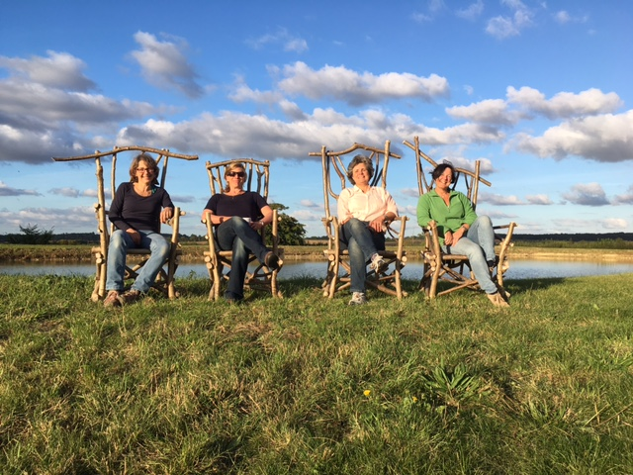

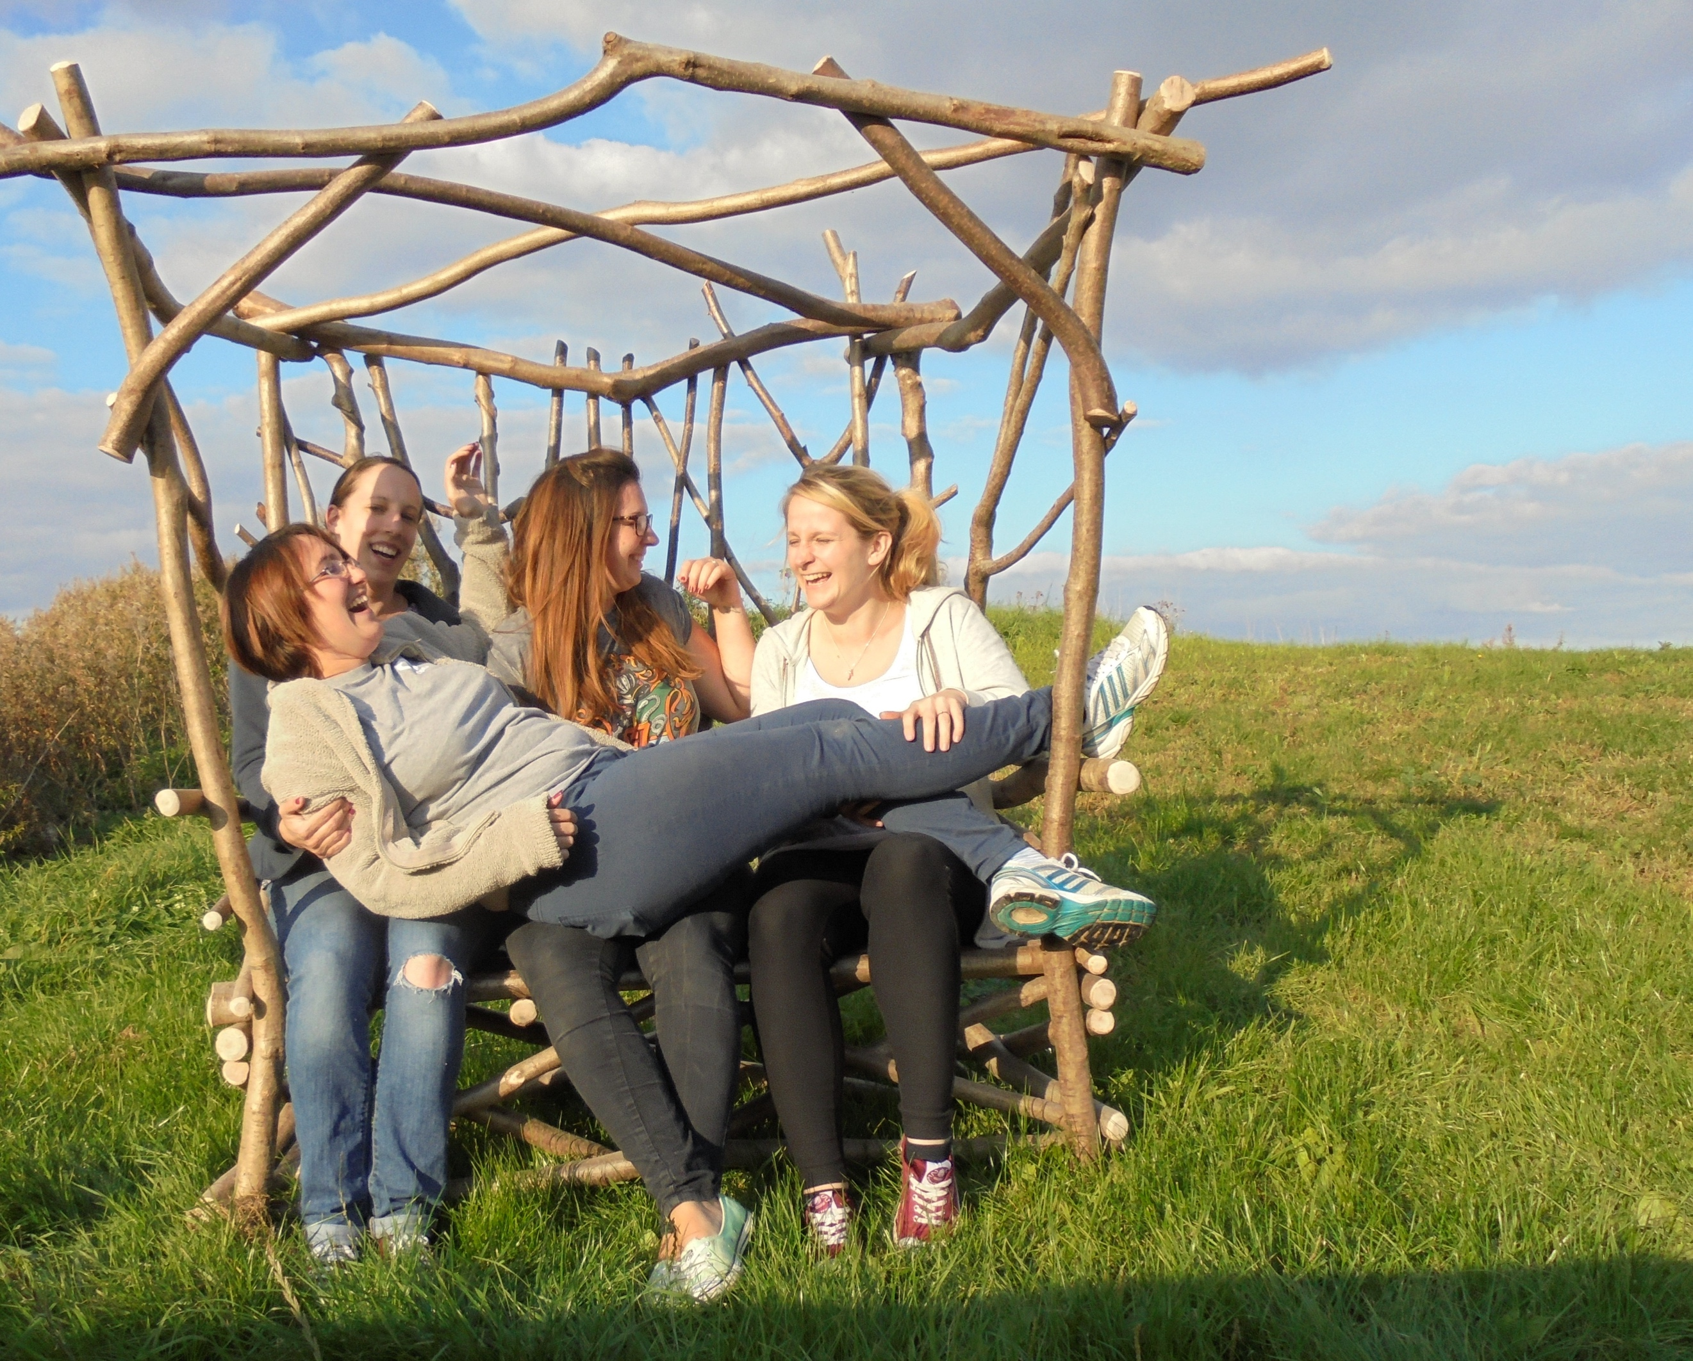

"Thank you so much for a really enjoyable day, luckily the weather has stayed dry and we have enjoyed sitting in our chairs!" Mick and Chris Lyons
"Just wanted to say thank you for a really great day yesterday. Norm and I both really enjoyed it!" Suzie Shannon
"Just a quick line to say "thank you" for a fabulous day today!
We have just returned home, with our chairs, of which we are very proud! What a great reminder of a brilliant day. We both learned new skills and had lots of fun in the process" Gwen and Stuart Thurtle, April 2013
"I wanted to say a great big thank you for making Daryn's day so enjoyable. He loves his chair and so does everyone else... it was the best present I have given Daryn for his birthday for a long time" - Frances, Feb 2013
"Thanks for an excellent course. My husband was 'impressed' with my effort - that might be a first" - Margaret
"Thank you for the time you spent with my father and I, instructing and assisting us to construct rustic chairs - we both thoroughly enjoyed the occasion" - Henrik P.
"I am writing to say how much I enjoyed the chair making course last week. You explained everything very clearly and simply, and we had everything we needed to hand in a lovely setting with a great atmosphere. I am really pleased with the chair that I made and would highly recomend the course - I am sure I will be back to make something else!" - Sarah, June 2013
"We're both looking forward to coming back and learning more" - Emma Lucas
"Thank you for your expertise, for your unending patience and for a thoroughly enjoyable day" - Maryann Matthews
"Many thanks for the photos, they are very good and a lovely reminder of a great day at your workshop" - Gill Hewitt
"The day I spent with you making a rustic chair was one of the best birthday treats I have ever had. The chair now has pride of place in our porch and has received may admiring and complimentary comments, mainly to the effect that they are amazed I made it in one day!" - Martin Sulley
"Andy,I would just like to thank you for Saturday, my sister Lyn was so pleased with her chair and enjoyed your course so much Our family wanted a special day for her and you provided it." - John Ditton
"Thanks for a great day - we both thoroughly enjoyed it." - Michelle and Owen Toon
"Thanks for such a great day. We all had an awesome time." - Rachel Garside
"Many thanks for a splendid day at your workshop yesterday. Howard and I really enjoyed creating our anniversary masterpiece" (bench) Phillipa and Howard Slatter, Cambridge
"Really enjoyed my day with you" Joe McWilliams
Many thanks for a great day and a super chair. I really enjoyed it. Your teaching was perfect......cheers, Bob Wells

"What a great day. Rich, I and the girls had a wonderful time, cheers." Alan Wingfield Gt Bradley
"Thanks again Andy for a great day yesterday." Steve Mowan, Harpenden
"Rachel and I had a lovely time and thoroughly enjoyed making our chairs." Laura Joy, herts.
"Thanks for a great day, our chairs are now sitting pride of place." Andrew Denny, Bury St Edmunds
"Cracking day yesterday Andy, thanks very much - much impressed with the final result ----- likes it so much, she wants it in the house." Phil Davis, Finchley.
"Thanks for a great day..." Jeff Clarke, Potters Bar
"Thanks very much for a great day - we had a lot of fun" Kim Thornton, S. London
"Thank you also for all your clear instruction and patience - I definitely now feel more confident using power tools!" Alice Coe, Wilshire
"Thank you again for the great day and your help and skill in making a great chair" Denise Steward, Ipswich
"We had an amazing day and achieved so much - very proud - and thoroughly enjoyed it - great teacher" Tracy Young, Ely.

“Thanks again for an awesome day” Caroline Miller

“ A short note of thanks for the excellent chair making session…..some great tuition and insight, together with good company…made the day exceptional. Oh and a great chair to take home. Andy Calver, Beds.

Andy…if my house was on fire I would rescue my chair first of all!! Sue, Suffolk.

Thanks again fir a great day – bench has been much admired recently! (Jane McDonald, made bench with friend for niece’s wedding.)

